KLH PANTRY APP: A REAL-TIME CAMPUS CANTEEN ORDERING AND MANAGEMENT SYSTEM
A Mini Project Report Submitted in the partial fulfillment of the requirements for the award of the degree of
BACHELOR OF TECHNOLOGY
In
DEPARTMENT OF COMPUTER SCIENCE AND ENGINEERING
By
Pujith krishna soma – 2420090069 (Team Lead)
Ch. Bharath Varma – 2420090068
Y Sriram – 2420090148
R Sai Sidhartha – 2400032486
Under the Esteemed Guidance of
Ms Navyatha Ravi


K L (Deemed to be) University
DEPARTMENT OF COMPUTER SCIENCE AND ENGINEERING
DECLARATION
The Mini Project Report entitled “KLH Pantry App: A Real-Time Campus Canteen Ordering and Management System” is a record of Bonafide work of Pujith krishna soma – 2420090069, Ch. Bharath Varma – 2420090068, Y Sriram – 2420090148, R Sai Sidhartha – 2400032486 submitted in partial fulfillment for the award of B.Tech in Computer Science and Engineering to the K L (Deemed to be) University. The results embodied in this report have not been copied from any other departments/University/Institute.

Pujith krishna soma – 2420090069
Ch. Bharath Varma – 2420090068
Y Sriram – 2420090148
R Sai Sidhartha – 2400032486
K L (Deemed to be) University
DEPARTMENT OF COMPUTER SCIENCE AND ENGINEERING
CERTIFICATE
This is to certify that the mini project based report entitled “KLH Pantry App: A Real-Time Campus Canteen Ordering and Management System” is a bonafide work done and submitted by Pujith krishna soma – 2420090069, Ch. Bharath Varma – 2420090068, Y Sriram – 2420090148, R Sai Sidhartha – 2400032486 in partial fulfillment of the requirements for the award of the degree of BACHELOR OF TECHNOLOGY in Computer Science and Engineering, K L (Deemed to be University), during the academic year 2026-2027.

Signature of the Course Co-ordinator |  | Signature of HOD
ACKNOWLEDGEMENT
The success of this project would not have been possible without the timely help and guidance of many people. We wish to express our sincere thanks to all those who assisted us, in one way or another, in the completion of our project.
Our greatest appreciation goes to our guide, Ms Navyatha Ravi, Department of Computer Science, whose tremendous support, encouragement and guidance for this project cannot be expressed in words.
We express our gratitude to Dr. P. Venkateshwar Sir (CSE), Head of the Department of Computer Science and Engineering, for providing us with adequate facilities, ways and means by which we were able to complete this project-based lab.
We thank all the members of the teaching and non-teaching staff who assisted us directly or indirectly in the successful completion of this project. Finally, we sincerely thank our parents, friends and classmates for their kind help and cooperation during our work.

Pujith krishna soma – 2420090069
Ch. Bharath Varma – 2420090068
Y Sriram – 2420090148
R Sai Sidhartha – 2400032486
TABLE OF CONTENTS
S.No. | Contents | Page no.
1 | Abstract | 1
2 | Introduction | 2
2.1 | Background and Motivation | 2
2.2 | Scope of the Project | 2
2.3 | Overview of the Proposed System | 3
2.4 | Organisation of the Report | 3
3 | Literature Survey | 4
4 | Problem Statement and Objectives | 7
5 | Hardware and Software Requirements | 8
6 | Implementation | 10
6.1 | System Architecture | 10
6.2 | Database Design | 11
6.3 | Backend (TypeScript, Hono) | 13
6.4 | Real-Time Layer (Server-Sent Events and Durable Objects) | 19
6.5 | Other Backend Features | 20
6.6 | Frontend (React, TypeScript, Tailwind CSS) | 21
6.7 | API Integration | 24
6.8 | Security Measures | 24
6.9 | Testing and Deployment | 25
7 | Results & Discussion | 26
7.1 | Automated Test Results | 32
7.2 | Discussion | 33
8 | Conclusion & Future Scope | 34
8.1 | Conclusion | 34
8.2 | Future Scope | 34
9 | References | 36

ABSTRACT
Campus canteens must serve thousands of students inside a few short break windows. The traditional model of standing in a queue, paying cash and calling out an order wastes time, hides stock-outs until the counter is reached and leaves the canteen with no reliable record of what was sold. This project presents the KLH Pantry App, deployed as the Raja's Bakery ordering platform, a real-time web system in which students of KLH University and DRK Institution browse a live menu, order from their phones, pay by UPI and collect food against a short order number, while kitchen staff run the counter from a live order board.
The system consists of a React 19 single-page application and a TypeScript REST API built with Hono on Cloudflare Workers, backed by serverless PostgreSQL on Neon. Stock is reserved atomically when an order is placed so that no item is oversold. Payments release an order to the kitchen only after the gateway's own check-status API confirms the money. Server-Sent Events delivered through Durable Objects keep every menu and order board current without polling. Role-based access, identity-based rate limiting, an audit log, Telegram notifications and year-end cohort promotion complete the platform. The implementation is verified by 485 automated tests (233 frontend and 252 backend) and is deployed at www.rajasbakery.in.
Team Name: [Team Name]
Team Logo (if any): [Insert team logo here, or write: Not applicable]
Team Members:
Name | Role | Contact Information
Pujith krishna soma (2420090069) | Team Lead | [E-mail / phone]
Ch. Bharath Varma (2420090068) | [Role] | [E-mail / phone]
Y Sriram (2420090148) | [Role] | [E-mail / phone]
R Sai Sidhartha (2400032486) | [Role] | [E-mail / phone]

INTRODUCTION

Background and Motivation
A university canteen is a high-volume, short-window food business. At KL University the same counters serve several thousand students, most of whom arrive within the same ten or fifteen minutes between classes. Orders are taken by hand, stock is tracked on paper or in memory, and the only signal that an item has run out is a customer being told so at the front of a long queue. Three problems follow directly from this: students lose break time waiting, the kitchen cannot see demand until it arrives at the counter, and the management has no dependable sales record for pricing, purchasing or settlement.
Consumer food-delivery apps solve a different problem. They assume a delivery fee, a rider and a menu owned by a restaurant, whereas a campus canteen needs pre-ordering for collection, a menu that differs by institution and kitchen, identity tied to the student roll number, and tight control of a small, fast-changing stock. The motivation for this project is therefore a purpose-built platform that treats the canteen counter as the centre of the workflow rather than a delivery address.

Scope of the Project
The project delivers a complete, deployed ordering platform covering the following scope:
- Student ordering for two institutions (KLH University and DRK Institution), each with its own menu, administrators and fee settings.
- Walk-up guest ordering at the counter through a printed QR code and a Google sign-in, without creating a student account.
- Two kitchens (Snacks and Meals); a cart that spans both is split automatically into one order per kitchen.
- Optional UPI payment through the GuruPay gateway, with server-side verification of every settlement.
- A live kitchen order board, inventory management, payment and payout reports, and a super-admin console for users, cohorts, platform fee and audit.
- Real-time updates to menus, boards and student tokens, and optional Telegram notifications.
Delivery of food to a location, native mobile applications and loyalty programmes are outside the present scope and are discussed under future work.

Overview of the Proposed System
The proposed system is a three-tier web application. The presentation tier is a role-aware React single-page application. The application tier is a stateless Hono API running on Cloudflare Workers, supported by two Durable Objects: one that fans real-time events out to connected browsers and one that keeps atomic rate-limit counters. The data tier is a Neon PostgreSQL database accessed with parameterised raw SQL. Figure 6.1 in the Implementation chapter shows the complete architecture.
A student signs in, sees the menu with live stock, adds items to a cart and places the order. The backend reserves the stock, writes the order and (when payments are enabled) sends the student to a hosted UPI page. When the payment is confirmed the order appears on the kitchen board and the student's phone shows a four-digit token. The kitchen marks the order cooked and then collected; the student's token changes state in real time.

Organisation of the Report
Chapter 3 surveys similar canteen-ordering projects. Chapter 4 states the problem and the objectives. Chapter 5 lists the hardware and software requirements. Chapter 6 describes the implementation: architecture, database, backend, real-time layer, frontend, third-party integrations, security and testing. Chapter 7 presents the results with screenshots and test outcomes. Chapter 8 concludes and outlines future scope, and Chapter 9 lists the references.

LITERATURE SURVEY
Eight similar projects were studied: seven open-source or student canteen-ordering systems and one published conference-style study. Each is summarised below from its public repository or paper; the URLs are listed in Chapter 9 (References).

QuickBite [1]
QuickBite is a web application that lets college canteen users pre-order meals before breaks and pay online to reduce queues. Its README lists Reflex, FastAPI, JWT authentication and Razorpay as the main technologies, and the features include a dynamic menu, a cart, a checkout flow and an order-management dashboard. The repository states benefits such as shorter waiting time and real-time inventory, but publishes no measurements, and items such as analytics and offline sync appear only as future plans.

CampusDine [2]
CampusDine is built with Express.js, React, Node.js and MySQL so that students can order food online while the canteen receives, prepares and manages pick-ups. Students browse the menu, place orders and track them, and canteen staff use a separate admin interface to manage menu items, update orders and track delivery. A backend API handles order processing, user management and storage. The repository description mentions no payment, stock-reservation or real-time push mechanism.

Canteen-Management-System (VIT food parks) [3]
This Node.js platform targets the food parks at VIT. Students pre-order from a menu and receive an email when the food is ready, so they do not have to wait in line, while staff update the daily food items. Payment is handled through a prepaid balance rather than a gateway. The repository does not name a database or web framework, and its description mentions no live board or stock-safety mechanism.

KCCafeteria [4]
KCCafeteria is a fifth-semester WDL and DBMS mini-project for the KCCEMSR campus. Users register, log in, pick their food and enter a mobile number and a classroom or lab location for delivery. It is built with HTML5, CSS3, Bootstrap 4, JavaScript, AJAX, PHP and MySQL and runs locally on XAMPP. It illustrates the classic LAMP-style approach; its description mentions no payment integration or live updates.

SCOS: Smart Canteen Ordering System [5]
SCOS lets students order food before heading to class and collect it at the cafeteria during busy lunch hours. It uses Django for the backend, Django templates for the frontend and an SQL database. Students pay through Razorpay, and staff manage menu items and check pending orders; both roles have separate logins and account pages. Because the pages are rendered from Django templates, the description mentions no push updates to the browser.

CampusBite [6]
CampusBite is a full-stack web application for ordering from college canteens. Students and faculty browse menus, pay through UPI apps such as GPay, PhonePe, Paytm or BHIM, and track orders in real time; pick-up is verified with a one-time password shown in the app. The stack is React 18 with Vite and Tailwind CSS, Node.js with Express, PostgreSQL and JWT authentication with refresh tokens. It is the closest of the surveyed systems to the present work, but its description does not mention multi-institution support.

College Canteen Management System (QR table ordering) [7]
This project lets customers scan a table QR code to browse the menu and place orders. It uses React 18 with TypeScript, Hono.js for the API, SQLite for storage and Tailwind CSS, and it relies on polling for updates. Admins get a live order dashboard, menu and table management with QR-code generation, order-status controls and basic sales tracking. Hono and TypeScript are shared with the present project; the description mentions no online payment or multi-institution support.

Quick-Eats at IoBM [8]
Quick-Eats is described in a 2025 paper in the Journal of Information and Communication Technology (ILMA University) as a mobile and online platform for campus canteens at the Institute of Business Management, Karachi. The platform features ordering, notifications and student registration with student IDs, and it mentions vendor advertising, analytics and cross-platform compatibility (React Native). The reported benefits, such as fewer classroom delays and higher vendor sales, are the authors' projections rather than measured results.

Comparison and Gap Analysis
Table 3.1 compares the surveyed systems with the present project on the features that matter most for a campus canteen. A dash means that the source does not state the feature.
Table 3.1: Comparison of the surveyed canteen systems
Project | Main technology | Online payment | Live updates | Multi-institution
QuickBite [1] | Reflex, FastAPI | Razorpay | - | -
CampusDine [2] | React, Express, MySQL | - | - | -
Canteen-Mgmt-System [3] | Node.js, SQL | Prepaid balance | E-mail on ready | -
KCCafeteria [4] | PHP, MySQL, Bootstrap | - | - | -
SCOS [5] | Django, SQL | Razorpay | - | -
CampusBite [6] | React, Express, PostgreSQL | UPI | Live tracking | -
QR ordering [7] | React, Hono, SQLite | - | Polling | -
Quick-Eats [8] | React Native | - | Notifications | -
KLH Pantry App | React 19, Hono, Neon | UPI, verified | SSE deltas | KLH + DRK

The survey shows that most student projects stop at a menu, a cart and an admin list. The present work extends the state of the art in six practical respects: (i) stock is reserved atomically at order time instead of being decremented after the fact; (ii) a payment settles an order only after the gateway's check-status API confirms it, because the gateway's webhook is unsigned; (iii) menus, fees, administrators and orders are scoped per institution; (iv) kitchens receive data-carrying real-time events rather than polling; (v) rate limiting is keyed on identity, not IP address, which is essential behind a campus NAT; and (vi) the platform is operated in production with an audit log, cohort promotion and payout reporting.

PROBLEM STATEMENT AND OBJECTIVES
Problem Statement: Campus canteens lose students' break time and sales to queues, manual order-taking and invisible stock, and need a reliable digital ordering platform.
Problem Description: Students must wait in long counter queues to order and pay, the kitchen cannot see demand or remaining stock in real time, and two students can be promised the last portion of an item; a system is needed that reserves stock safely, verifies payment independently and updates every screen live.
Objectives:
The project purpose is to replace counter queues with pre-ordering and to give the canteen a trustworthy, real-time operating tool. The objectives framed from that purpose are:
- Provide students with a fast, mobile-friendly ordering experience that shows live menu and stock for their own institution.
- Guarantee that stock is never oversold, even when many students order the same item at the same moment.
- Accept UPI payments and release an order to the kitchen only after the payment has been independently verified with the gateway.
- Give kitchen staff a live order board and a short, non-guessable collection token for every order.
- Support walk-up guests at the counter through a QR code, without requiring a student account.
- Enforce role-based access for students, guests, kitchen admins and super admins, with an audit trail of administrative actions.
- Keep every menu, order board and student token current in real time without repeated full refreshes.
- Deploy the platform on a serverless stack that scales with lunch-hour demand and verify it with an automated test suite.

HARDWARE AND SOFTWARE REQUIREMENTS
Hardware Requirements:
- Development workstation: x64 laptop or desktop with a quad-core processor, 8 GB RAM (16 GB recommended when running Docker, the Vite dev server and the test suites together) and 20 GB of free SSD space.
- Server infrastructure: no dedicated hardware; the API runs on Cloudflare Workers, the database on Neon and the frontend on Vercel (all serverless / managed).
- Customer devices: any smartphone, tablet or PC with a current Chrome, Edge, Firefox or Safari browser that supports EventSource (Server-Sent Events).
- Counter devices: a tablet or monitor of 10 inches or larger for the kitchen order board, and a printed QR code for walk-up guests.
- Network: internet access through campus Wi-Fi or mobile data.
Software Requirements:
Table 5.1: Software and tools used
Category | Software | Version / note | Purpose
Runtime | Node.js and npm | Node 24.x, npm 11 | Build tooling, local server, tests
Language | TypeScript | 6.0 (frontend), 5.9 (backend) | Typed source for both tiers
Frontend | React and React DOM | 19.2 | Single-page user interface
Frontend | Vite | 8.1 | Dev server and production bundler
Frontend | Tailwind CSS | 4.3 | Utility-first styling
Frontend | React Router | 7.18 | Client-side routing and guards
Frontend | Recharts, jsPDF, Lucide | 3.10, 4.2, 1.x | Charts, PDF export, icons
Backend | Hono | 4.13 | HTTP framework for Workers
Backend | Zod | 4.4 | Request validation
Backend | @neondatabase/serverless | 1.1 | PostgreSQL driver (WebSocket / HTTP)
Backend | bcryptjs, jsonwebtoken | 3.0, 9.0 | Password hashing, signed tokens
Backend | csv-parse | 7.0 | Bulk student import
Platform | Wrangler (Cloudflare) | 4.x | Local Workers runtime and deployment
Database | PostgreSQL | 16 | Local development database (Docker)
Testing | Vitest, Testing Library, fast-check | 4.1, 16.3, 4.9 | Unit, component and property tests
Testing | Supertest, Playwright | 7.2, 1.62 | API tests, end-to-end browser tests
Tooling | Docker Desktop, Git, VS Code | Current | Containers, version control, editor
Quality | oxlint | 1.71 | Linting

Table 5.2: External services and accounts
Service | Role in the system
Cloudflare Workers, Durable Objects, KV | Hosts the API, the real-time hub and the rate-limit counters
Neon (serverless PostgreSQL) | Primary database
Vercel | Hosts the single-page application
Google Cloud OAuth clients (KLH, DRK, Guest) | Verified Google ID tokens for sign-in
GuruPay payment gateway | UPI checkout and independent payment status
Telegram Bot API | Optional order-ready notifications

Operating System: Development was carried out on Windows 11; the deployed system is operating-system independent (browser on the client, Workers on the server).

IMPLEMENTATION
Frontend: React 19 and TypeScript single-page application, built with Vite, styled with Tailwind CSS and routed with React Router.
Backend: Hono REST API in TypeScript on Cloudflare Workers with raw parameterised SQL on Neon PostgreSQL.
API Integration: Google Identity (sign-in), GuruPay (UPI payments), Telegram Bot API (notifications) and Server-Sent Events (real time).
The two code bases together contain about 30,000 lines of TypeScript (14,043 lines in 66 backend source files and 16,649 lines in 89 frontend source files, excluding tests).

System Architecture
Figure 6.1 shows the architecture. Users reach the single-page application, which talks to the Hono API over HTTPS with a bearer JWT and receives push events over one Server-Sent Events stream. The API is the only component that touches the database or the third-party services. Two Durable Objects extend the stateless Worker: OrderEventsHub holds the live connections, and RateLimiterHub holds atomic counters.
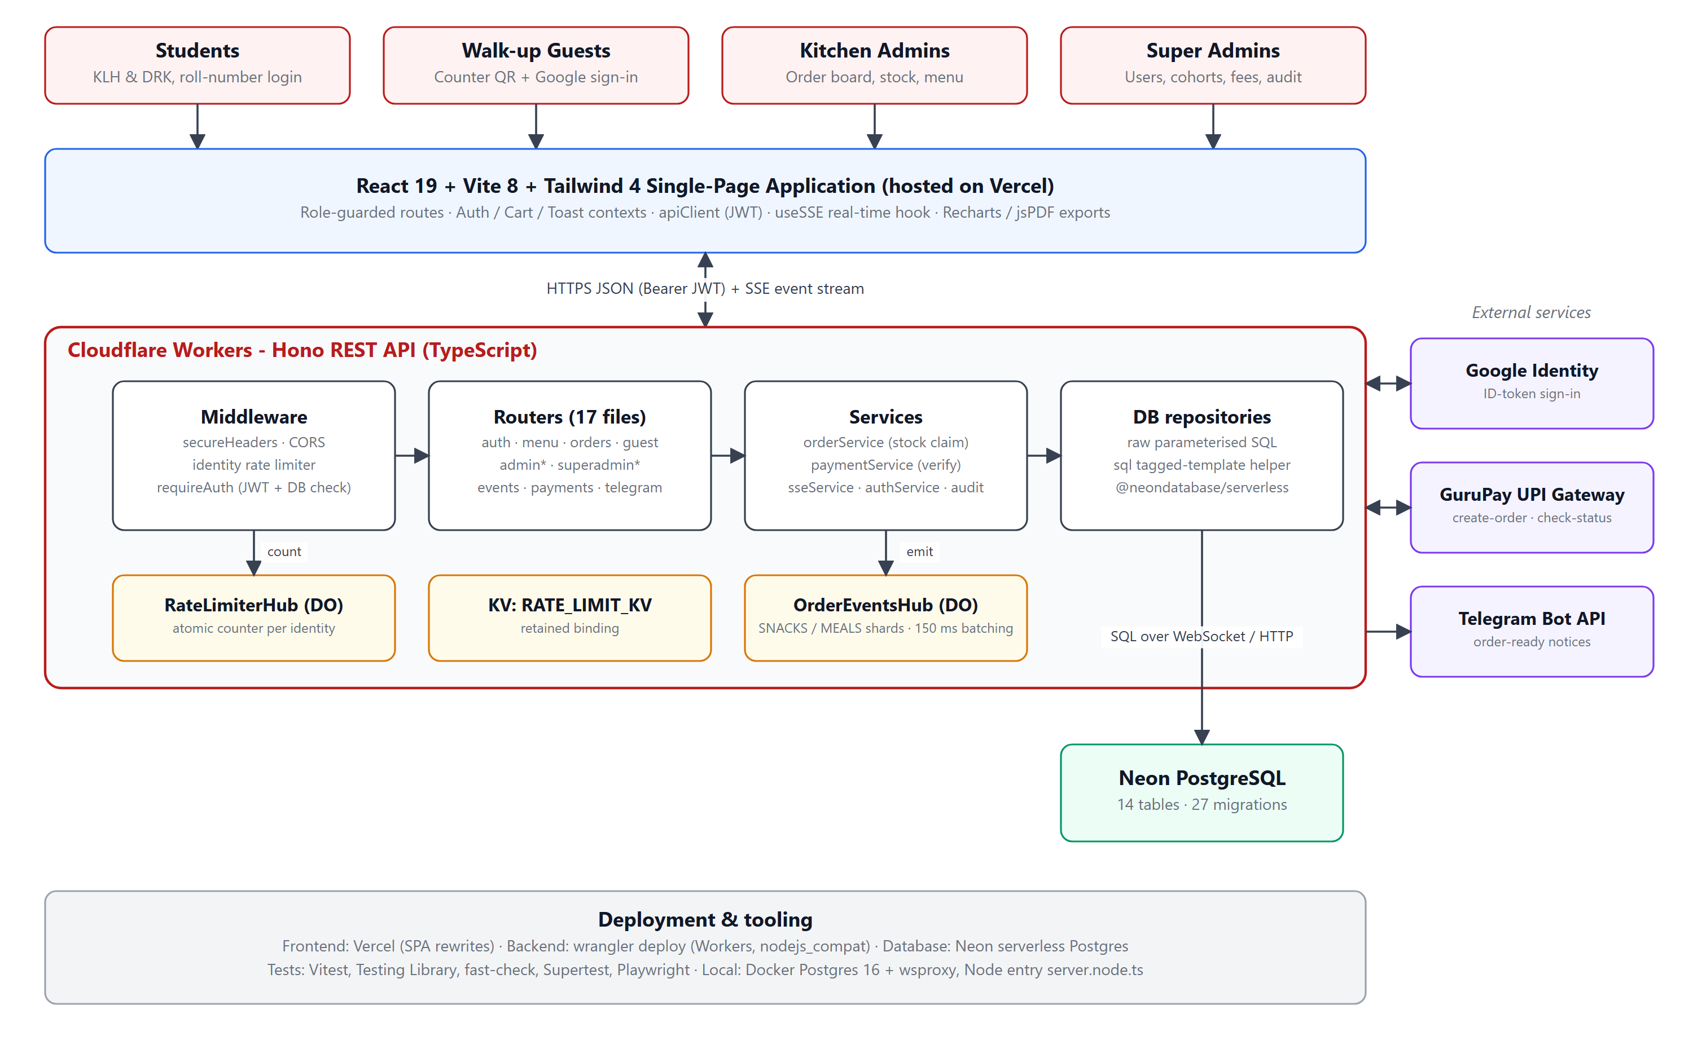
Figure 6.1: System architecture of the KLH Pantry App

Database Design
The schema has 14 tables created by 27 timestamped SQL migrations that are applied in order by scripts/migrate.ts and tracked in a _migrations table. Money is stored as numeric and handled as strings at the API boundary to avoid floating-point error. Figure 6.2 shows the core entities and Table 6.1 describes each table.
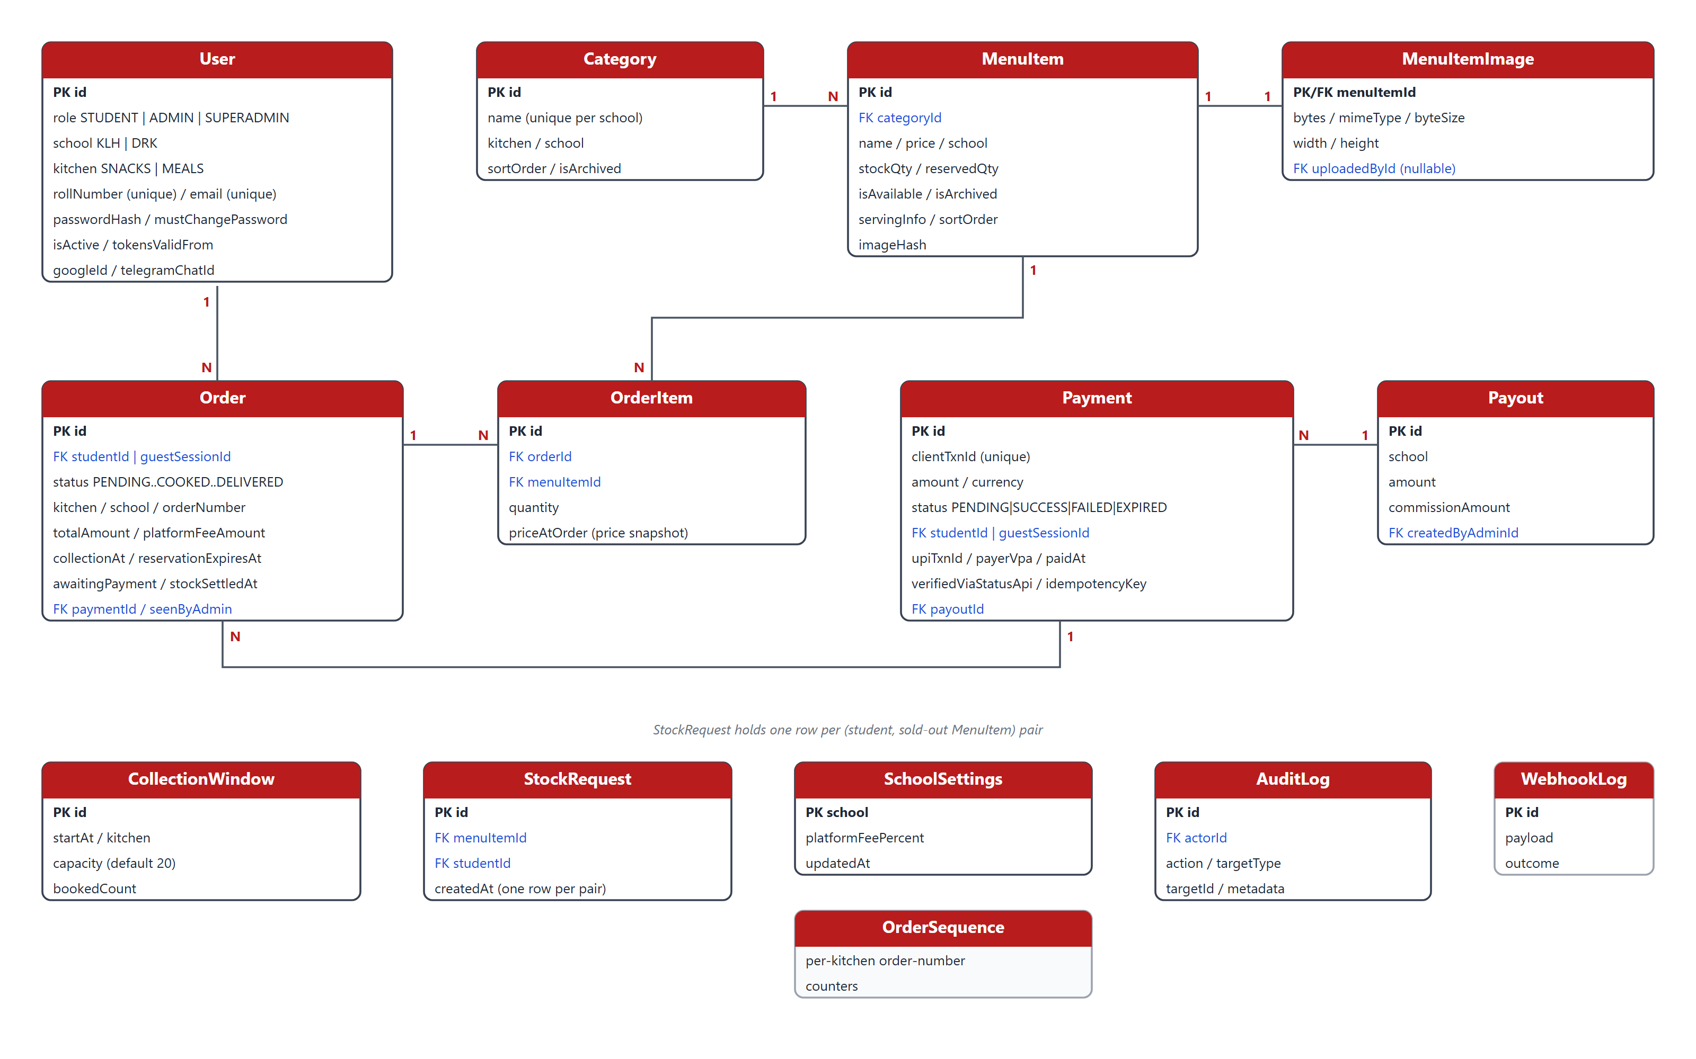
Figure 6.2: Entity-relationship diagram of the core tables
Table 6.1: Database tables
Table | Purpose
User | Students, admins and super admins; role, school, kitchen, password hash, activation and token-revocation fields, Google and Telegram links.
Category, MenuItem | Per-school menu. MenuItem carries stockQty and reservedQty; both tables are soft-deleted (isArchived) because orders reference them.
MenuItemImage | Uploaded item images stored as compressed bytes, addressed by content hash.
Order, OrderItem | One order per kitchen, with a snapshot of the unit price and platform fee for every line.
Payment, WebhookLog | UPI payment records and a log of every gateway webhook received; one payment can cover several orders.
Payout | Settlement records and the commission retained per school.
CollectionWindow | 15-minute pick-up slots per kitchen with capacity and booked count (pre-booking).
StockRequest | A student's request to be notified when a sold-out item returns.
SchoolSettings | Super-admin editable platform-fee percentage per school.
AuditLog | Who did what to which record, written best-effort so a log failure never blocks an action.
OrderSequence | Legacy order counter, superseded by random open-order numbers.

Order numbers are random four-digit tokens rather than a counter. A partial unique index (kitchen, orderNumber) WHERE status NOT IN ('DELIVERED','CANCELLED') makes Postgres itself guarantee that no two open orders of one kitchen share a number, and a delivered or cancelled order frees its number immediately. The application picks a number and retries if the index rejects it. A token that cannot be guessed from the previous one also prevents a student from reading someone else's order number.

SQL access layer
The Prisma client used in an earlier version was replaced by a small tagged-template helper in src/db/sql.ts. Every interpolated value becomes a positional parameter ($1, $2, ...), so injection is structurally impossible, and fragments compose by renumbering their placeholders.
klh-canteen-backend/src/db/sql.ts (lines 26-42)
export function sql(strings: TemplateStringsArray, ...exprs: unknown[]): SqlFragment {
let text = strings[0];
const values: unknown[] = [];
for (let i = 0; i < exprs.length; i++) {
const e = exprs[i];
if (isFragment(e)) {
const offset = values.length;
text += e.text.replace(/\$(\d+)/g, (_, n) => `$${offset + Number(n)}`);
values.push(...e.values);
} else {
values.push(e);
text += `$${values.length}`;
}
text += strings[i + 1];
}
return { text, values };
}

Backend (TypeScript, Hono)
The API follows a strict layering: routers validate input and call services; services hold the business rules; repositories run SQL. Table 6.2 lists the main modules.
Table 6.2: Backend modules
File | Responsibility
src/app.ts | Builds the Hono app: secure headers, CORS allow-list, request logger, global identity rate limit, /health, /config and all routers.
src/index.ts, src/server.node.ts | Workers entry point and the plain-Node entry used for local development and tests.
middleware/auth.ts | JWT verification followed by a database check of the account; role and forced-password-change gates.
middleware/rateLimit.ts | Identity-keyed limiter with reject and progressive-delay strategies backed by a Durable Object.
services/orderService.ts | Order creation, stock claim and release, reservations and their expiry sweep, collection windows, status transitions, cancellation, statistics.
services/paymentService.ts | GuruPay checkout, status confirmation, idempotent webhook settlement, expiry sweep and reconciliation.
services/authService.ts, googleAuthService.ts | Password login, password change, logout-everywhere, Google ID-token verification.
services/guestSessionService.ts, googleGuestService.ts | Stateless HMAC guest sessions and Google-derived stable guest ids.
services/sseService.ts, durableObjects/ | Event emission to the hubs and the hub implementation.
services/menuService.ts, menuImageService.ts | Menu CRUD, per-school scoping, image validation and compression.
services/cohortService.ts, studentRosterService.ts | Year-end cohort promotion and CSV bulk import of students.
services/telegramService.ts | Deep-link code, webhook and notification delivery.
services/payoutService.ts, adminPaymentService.ts | Pending commission, payout creation and payment reports.
services/auditService.ts | Best-effort audit writes.

Table 6.3 summarises the API surface: 70-plus endpoints in 17 router files, each guarded by the role shown.
Table 6.3: API endpoint summary
Router (base path) | Representative endpoints | Access
auth (/auth) | POST /login, /login/google, /login/google/klh/start|complete; GET /me; POST /logout-everywhere, /admin/reset-password | Public / any user
menu (/menu) | GET /; GET /items/:id/image/:hash | Public
orders (/orders) | POST /; GET /my, /:id, /collection-windows; POST /:id/cancel, /stock-requests/:menuItemId | Student
guest (/guest) | POST /session, /session/google, /orders; GET /orders, /orders/:id, /collection-windows | Guest session
adminMenu (/admin) | POST/PATCH/DELETE /categories, /menu-items; image upload; GET /stock-requests | Admin
adminOrders (/admin/orders) | GET /, /stats, /:id; PATCH /:id/status | Admin
adminPayments (/admin/payments) | GET /, /stats, /payouts/pending, /payouts/logs; POST /payouts | Admin
payments (/payments) | POST /checkout; GET /:id; POST /webhook (gateway, unsigned) | Student / guest / gateway
events (/events) | GET /stream (SSE), /ws, /meta | Any session
telegram (/telegram) | GET /; POST /link; DELETE /; POST /webhook | Student / Telegram
superadmin* (/superadmin) | users CRUD and bulk (de)activation; students bulk; cohorts preview/promote; orders.csv export; platform-fee settings; audit-log; storage | Super admin

Middleware stack
Every request passes through the same ordered stack. Secure headers are the outermost layer; a small follow-up middleware restores a Cross-Origin-Resource-Policy header only when a route (the public image endpoint) has not chosen its own. CORS is resolved per request against a comma-separated allow-list, and the global limiter allows 100 requests per minute per identity.
klh-canteen-backend/src/app.ts (lines 59-59, 70-70, 75-78, 85-94)
app.use("*", secureHeaders({ crossOriginResourcePolicy: false }));
// ...
app.use("*", logger());
// ...
app.use("*", async (c, next) => {
const { CORS_ORIGIN } = env<{ CORS_ORIGIN?: string }>(c);
return cors({ origin: resolveAllowedOrigins(CORS_ORIGIN) })(c, next);
});
// ...
app.use(
"*",
rateLimit({
prefix: "global",
windowSeconds: 60,
max: 100,
code: "TOO_MANY_REQUESTS",
message: "Too many requests, please try again later.",
})
);

Authentication and authorisation
A JWT proves who is calling but is only a twelve-hour snapshot, so requireAuth follows signature checking with a primary-key lookup of the account. A deleted account, a deactivated account and a token issued before the user's tokensValidFrom are all refused, and the role is taken from the database row rather than the token so a role change applies on the next request. Login returns the same generic error for an unknown user, a wrong password and a wrong school so that the endpoint cannot be used to enumerate accounts.
klh-canteen-backend/src/middleware/auth.ts (lines 103-115)
const user = await resolveSessionUser(c, payload.sub);

// The account is gone. Its token is still cryptographically valid and will
// stay that way for up to 12 hours; this is the check that stops it.
if (!user) {
throw new ApiError(401, "USER_NOT_FOUND", "Account no longer exists");
}
if (!user.isActive) {
throw new ApiError(401, "ACCOUNT_DEACTIVATED", "This account has been deactivated");
}
if (isTokenRevoked(payload.iat!, user.tokensValidFrom)) {
throw new ApiError(401, "TOKEN_REVOKED", "This session has been signed out. Please sign in again.");
}

Stock reservation and order creation
Order creation is the heart of the system. Instead of a long transaction that locks rows across network round trips, createOrder uses two short atomic statements: (1) claim the stock, and (2) write the orders and their items. The claim is a single conditional UPDATE that succeeds for an item only if stockQty - reservedQty >= qty, so concurrent baskets can never oversell an item and no row lock is held across the network. If only part of a basket is claimed, or the insert fails, the claim is handed straight back; if a Worker is killed between the two statements a reconciliation job rebuilds reservedQty from the order ledger. A cart spanning both kitchens becomes two orders, each with its own number, price snapshot and platform fee.
klh-canteen-backend/src/services/orderService.ts (lines 171-186)
async function claimStock(db: RawRunner, claims: StockClaim[]): Promise<Set<string>> {
const { rows: claimed } = await query<{ id: string }>(
db,
sql`
UPDATE "MenuItem" m
SET "reservedQty" = m."reservedQty" + r.qty
FROM (VALUES ${claimValues(claims)}) AS r(id, qty)
WHERE m.id = r.id
AND m."isAvailable" = TRUE
AND m."isArchived" = FALSE
AND m."stockQty" - m."reservedQty" >= r.qty
RETURNING m.id
`,
);
return new Set(claimed.map((row) => row.id));
}

Unpaid reservations expire (four hours for walk-in orders; two hours after the slot for pre-booked ones) and are released by a sweeper. Pre-booking uses 15-minute collection windows with a default capacity of 20 orders per kitchen. Status moves along a fixed path that the server enforces, so a request to skip a step is rejected with INVALID_TRANSITION:
klh-canteen-backend/src/services/orderService.ts (lines 1297-1301)
const NEXT_STATUS: Record<string, string> = {
PENDING: "COOKED",
PREPARING: "COOKED",
COOKED: "DELIVERED",
};

Payment verification
GuruPay signs nothing: its webhook carries no secret or signature. The webhook is therefore treated as a hint and never as evidence. applyWebhook uses it only to find which payment is meant, asks GuruPay's check-status API what really happened, discards the payload's claim, compares the reported amount with the stored amount to the paisa, and settles inside a transaction that locks the payment row (FOR UPDATE) so that two concurrent deliveries of the same event cannot both confirm the orders. If the gateway cannot be reached nothing is settled; the status poll and the expiry sweep still pick up a genuine payment moments later. Figure 6.3 shows the whole life of an order.
klh-canteen-backend/src/services/paymentService.ts (excerpt: the gateway answer replaces the payload)
if (truth.status !== claimed) {
// Worth shouting about: either GuruPay changed its mind between sending
// the webhook and answering us, or the delivery was replayed from a
// leaked secret against a payment that has since moved on.
console.warn(
"[payments] webhook disagrees with the gateway",
{ claimed, actual: truth.status, paymentId: found.id },
);
}
// The gateway wins, always.
incoming = truth.status;

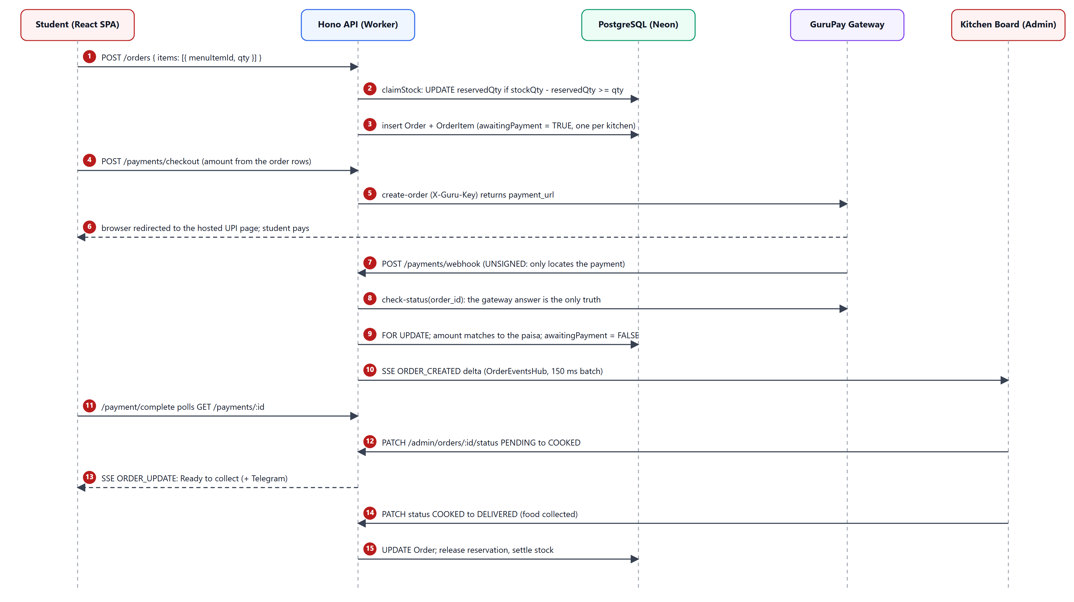
Figure 6.3: Order, payment and fulfilment sequence

Identity-based rate limiting
Campus Wi-Fi places the whole student body behind a handful of public addresses, so an IP-keyed limit would either throttle hundreds of innocent students or protect nothing. Every limit therefore keys on who is calling: the JWT subject on authenticated routes and the submitted campus id at login. Counters live in the RateLimiterHub Durable Object, which increments atomically (a KV get-then-put was replaced because it is not atomic). Routes where the key is attacker-supplied, above all login, use a progressive delay that doubles with each attempt over the limit and never refuses outright; a hard lock-out there would let anyone disable a classmate's account by spamming wrong passwords against their roll number.
klh-canteen-backend/src/middleware/rateLimit.ts (lines 186-192)
const baseMs = options.delay?.baseMs ?? DEFAULT_DELAY_BASE_MS;
const maxMs = options.delay?.maxMs ?? DEFAULT_DELAY_MAX_MS;
const overage = attempts - options.max;
const delayMs = Math.min(baseMs * 2 ** (overage - 1), maxMs);

await sleep(delayMs);

Real-Time Layer (Server-Sent Events and Durable Objects)
The first version of the real-time layer only told clients that something had changed, and every client answered with a full refetch; one order during a lunch rush caused one GET /menu per connected student. Version 2 of the protocol carries the change itself: each frame contains a deltas array (STOCK, ORDER_CREATED, ORDER_STATUS, ORDER_SEEN, STOCK_REQUEST) and clients patch their local state instead of refetching.
- Sharding: one OrderEventsHub instance per kitchen (SNACKS, MEALS). Kitchen boards connect to their own shard; students are spread over both shards with a deterministic FNV-1a hash of their id so that a reconnecting client lands on the shard that holds its resume cursor.
- Coalescing: an emit is appended to a persisted queue and an alarm fires after 150 ms; everything that arrived in that window is grouped by event type and audience into one frame carrying N deltas (at most about seven fan-outs per second regardless of order rate).
- Hibernation: WebSocket clients use the Hibernation API so an idle hub is evicted from memory while connections stay open.
- Resume: every frame has a per-shard sequence number and is kept in a short retention log (500 frames or 10 minutes). A reconnecting EventSource sends Last-Event-ID and receives the frames it missed; only when its cursor is older than the log does it get one SYNC_REQUIRED and refetch.
klh-canteen-backend/src/lib/realtime.ts (lines 66-75)
export function shardForSubject(subjectId: string): HubShard {
// FNV-1a, 32-bit. Small, dependency-free, and stable across isolates.
let hash = 0x811c9dc5;
for (let i = 0; i < subjectId.length; i++) {
hash ^= subjectId.charCodeAt(i);
hash = Math.imul(hash, 0x01000193) >>> 0;
}
return HUB_SHARDS[hash % HUB_SHARDS.length]!;
}

klh-canteen-backend/wrangler.jsonc (Durable Object bindings)
"durable_objects": {
"bindings": [
{
"name": "ORDER_EVENTS_HUB",
"class_name": "OrderEventsHub"
},
// Atomic fixed-window rate limit counters (identity-keyed: JWT subject
// on authenticated routes, submitted campus ID at login — never IP).
// Sharded one instance per (prefix, identity), so no single object
// serialises app-wide traffic.
{
"name": "RATE_LIMITER_HUB",
"class_name": "RateLimiterHub"
}
]
},

Other Backend Features
- Walk-up guests: a guest session is a signed bearer (HMAC over a random session id, signed with QR_TOKEN_SECRET) with its own expiry. Every guest read is scoped by the recovered session id. Signing in with Google derives a stable session id from the Google subject so the same person recovers their tickets on any device, yet no User row is created and no student or admin endpoint is reachable.
- Platform fee and payouts: the super admin sets a fee percentage per school; the amount is snapshotted into each order's total so later changes do not rewrite history. Admins see pending commission and record payouts.
- Cohort promotion: roll numbers encode the intake year, so a prefix selects a cohort. Promotion is a dry-run by default and soft-deactivates accounts; it never deletes, so past orders stay attributed.
- Bulk student import: a CSV of names and roll numbers creates accounts that must change their initial password at first login.
- Stock requests: a student can ask to be told when a sold-out item returns; the admin sends one notification and the requests are cleared.
- Telegram: a student links a chat through a one-time deep link (valid 15 minutes); order notifications are sent when an order is placed, paid, cancelled or changes status, and delivery failures are logged and swallowed so an outage never fails an order write.
- Audit log: administrative actions are written best-effort to AuditLog and shown in the super-admin console.

Frontend (React, TypeScript, Tailwind CSS)
The frontend is a single-page application of 89 source files. All pages are loaded lazily; a wrapper (lazyRoute) recovers once from a stale deploy by reloading when a retired chunk fails to load, which prevents the confusing error screen that otherwise follows a release. Table 6.4 maps the routes to their page files.
Table 6.4: Frontend routes and pages
Route | Page component (src/pages) | Role | Purpose
/login, /login/:school | LoginPage.tsx | Public | School selection, password login and Google sign-in
/student | StudentMenuPage.tsx | Student | Live menu, search, category tabs, cart bar
/student/checkout | CheckoutPage.tsx | Student | Order summary, kitchen split notice, payment start
/student/order/:id | OrderTokenPage.tsx | Student | Collection token and live order status
/student/orders | OrderHistoryPage.tsx | Student | Past and active orders
/student/telegram | TelegramSettingsPage.tsx | Student | Link or unlink Telegram
/payment/complete | PaymentCompletePage.tsx | Public | Polls the backend after the gateway redirect
/g, /g/checkout, /g/orders, /g/order/:ids | Guest pages (5 files) | Guest | Counter ordering behind a Google sign-in gate
/admin/board | AdminOrderBoardPage.tsx | Admin | Live kitchen board and status buttons
/admin, /admin/inventory | AdminDashboardPage, AdminMenuPage | Admin | Statistics, low-stock alerts, menu and stock editor
/admin/logs, /admin/payments | AdminLogsPage, AdminPaymentsPage | Admin | Order history, payment and payout reports
/admin/users, /students, /cohorts | AdminUsersPage, AdminStudentsPage, AdminCohortsPage | Super admin | Account management, bulk import, promotion
/admin/system, /platform-fee, /audit-log | SuperAdminDashboardPage and others | Super admin | Storage, fee settings, audit trail

Routing and role guards
ProtectedRoute wraps each role group. A super admin may enter the admin routes, but the user-management routes are closed to everyone else (allowSuperAdmin={false} there means only a super admin passes). The server repeats every check, so the guard is a convenience and never the security boundary. After login each role lands on its home screen: staff go straight to the order board because that is what the counter watches.
klh-canteen-frontend/src/App.tsx (lines 85-91, 101-109)
<Route element={<ProtectedRoute role="STUDENT" />}>
<Route path="/student" element={<StudentMenuPage />} />
<Route path="/student/checkout" element={<CheckoutPage />} />
<Route path="/student/order/:id" element={<OrderTokenPage />} />
<Route path="/student/orders" element={<OrderHistoryPage />} />
<Route path="/student/telegram" element={<TelegramSettingsPage />} />
</Route>
// ...
<Route element={<ProtectedRoute role="SUPERADMIN" allowSuperAdmin={false} />}>
<Route path="/superadmin" element={<Navigate to="/admin" replace />} />
<Route path="/admin/students" element={<AdminStudentsPage />} />
<Route path="/admin/users" element={<AdminUsersPage />} />
<Route path="/admin/cohorts" element={<AdminCohortsPage />} />
<Route path="/admin/system" element={<SuperAdminDashboardPage />} />
<Route path="/admin/platform-fee" element={<SuperAdminPlatformFeePage />} />
<Route path="/admin/audit-log" element={<AdminAuditLogPage />} />
</Route>

klh-canteen-frontend/src/lib/landing.ts (lines 9-19)
export function landingPathFor(role: string | null): string {
switch (role) {
case "ADMIN":
case "SUPERADMIN":
return "/admin/board";
case "STUDENT":
return "/student";
default:
return "/login";
}
}

State, API client and cart rules
Authentication, cart, toast and stock-alert state live in React contexts; the session is stored in localStorage under one key. A single apiClient wraps fetch, unwraps the { error: { code, message } } envelope into an ApiClientError and, when a request that carried a token returns 401, tells the auth context to end that session. The cart clamps every quantity to the known stock ceiling and never lets a malformed stock figure read as unlimited.
klh-canteen-frontend/src/lib/apiClient.ts (lines 60-66)
if (res.status === 401 && token) {
// Pass the token that failed. A request begun under a previous session can
// land after someone else has logged in on the same device, and tearing
// down THAT session would be wrong — the receiver compares before acting.
unauthorizedHandler?.(token);
}

klh-canteen-frontend/src/context/CartContext.tsx (lines 39-46)
export function clampQty(qty: number, stockQty: number): number {
// Both arguments are guarded, not just `qty`: every caller today pre-sanitizes
// the ceiling through safeStock(), and a future one that forgets would otherwise
// push NaN straight into a cart line.
const ceiling = Math.max(1, safeStock(stockQty));
if (!Number.isFinite(qty)) return 1;
return Math.min(Math.max(1, Math.floor(qty)), ceiling);
}

Real-time hook
useSSE opens one EventSource, subscribes to the requested event types and patches local state from the deltas. It falls back to a full refetch only for SYNC_REQUIRED, a FULL_REFRESH delta, an event without v: 2, or a reconnect that the server could not resume. Because EventSource cannot set headers, the token is passed in the query string, which is why the guest credential uses a separately named parameter.
klh-canteen-frontend/src/hooks/useSSE.ts (lines 158-167)
eventSource.onerror = (err) => {
setConnected(false);
// EventSource fires onerror on every routine reconnect too. Only surface a
// real failure — otherwise a normal idle-timeout looks like a broken app.
if (eventSource.readyState === EventSource.CLOSED) {
console.error("SSE connection closed:", err);
setError(new Error("SSE connection error"));
}
};

Design of the interface
The interface uses a red and white brand palette, large touch targets and a bottom cart bar on phones. The student menu is one screen of category tabs, a search box and a Hide sold out filter; the kitchen board shows each open order as a colour-coded tile that can be tapped for details; the order token is blurred until the student chooses Show token, so it is not exposed to people standing behind them in the queue.

API Integration
Table 6.5: Third-party integrations
Integration | How it is used | Safeguard
Google Identity Services | The browser obtains a Google ID token; the backend verifies it and checks the aud claim against the client id for that flow. | Three separate OAuth clients (KLH, DRK, Guest), so a token minted for one flow cannot be replayed in another.
GuruPay (UPI) | create-order returns a hosted payment_url; check-status reports the real outcome; the webhook is only a hint. | Amount recomputed from order rows, amount compared to the paisa, idempotency key, row lock, reconciliation and 15-minute expiry.
Telegram Bot API | A deep link stores the student's chat id; messages are sent when an order is placed, paid, cancelled or changes status. | Link code expires in 15 minutes; staff and guests are never linked; failures never fail an order.
Server-Sent Events | GET /events/stream keeps a long-lived response open per client. | Per-user subscription scope; resume log; SYNC_REQUIRED fallback.

Secrets (JWT_SECRET, QR_TOKEN_SECRET, DATABASE_URL, the Telegram and GuruPay credentials) are never committed: they are set with wrangler secret put, while non-sensitive values such as the CORS allow-list, the public OAuth client ids and the payments flag are plain variables in wrangler.jsonc.

Security Measures
- Passwords are hashed with bcrypt; a successful login transparently re-hashes an old hash with the current cost factor.
- Tokens expire after 12 hours and can be revoked at once (tokensValidFrom) by logout-everywhere or a password change; the database row is consulted on every request.
- A forced-password-change gate is enforced server-side for imported accounts, not merely by a frontend screen.
- All SQL is parameterised; all request bodies are validated with Zod; the response never reveals whether an account, a school or an activation state was the reason for a login failure.
- Secure response headers, a CORS allow-list, identity-based rate limits and per-route limiters protect the API.
- The payment trust model, guest-session scoping and school scoping (a KLH admin cannot see DRK orders) are enforced in the service layer.
- Soft deletes and ON DELETE RESTRICT keep the financial and audit history intact.

Testing and Deployment
Backend tests (Vitest and Supertest) run against a real PostgreSQL database. A guard refuses to run unless the target is a disposable database (it compares host, port and database name with the live .env, requires the name to look like a test database and refuses a database that already contains users or orders). npm run test:db:up starts PostgreSQL 16 plus Neon's wsproxy in Docker so that the serverless driver, which speaks WebSockets, can reach a local server. Frontend tests use Vitest with Testing Library and fast-check property tests; one Playwright specification covers login, and a custom Node harness under e2e/load supports load testing.
The frontend is deployed to Vercel with SPA rewrites; the backend is deployed with wrangler deploy. Durable Object classes are created by the migration tags in wrangler.jsonc, and database migrations are run from a developer machine with npm run migrate:deploy.

RESULTS & DISCUSSION
The screenshots below were captured from the running application. The two sign-in pages come from the deployed site (www.rajasbakery.in); all other screens were captured from a local instance seeded with demonstration users, a six-item menu and ten sample orders, so that no real student data appears in this report.
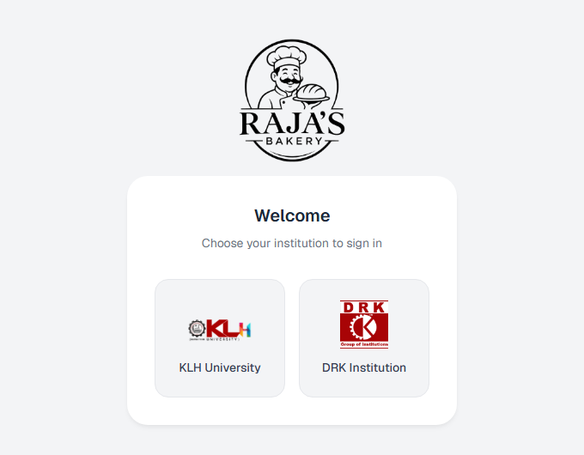
Figure 7.1: School selection page
Every visitor first chooses KLH University or DRK Institution; the choice scopes the menu, the login and the fee settings. The page is also reachable directly from a printed QR code at /login/KLH or /login/DRK.
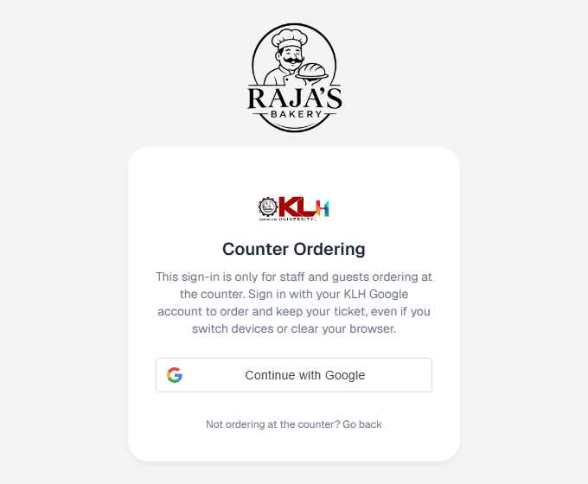
Figure 7.2: Counter ordering sign-in for walk-up guests
Guests ordering at the counter sign in with a KLH Google account, which gives them a persistent ticket without creating a student account. The same tickets can be recovered after switching devices or clearing the browser.
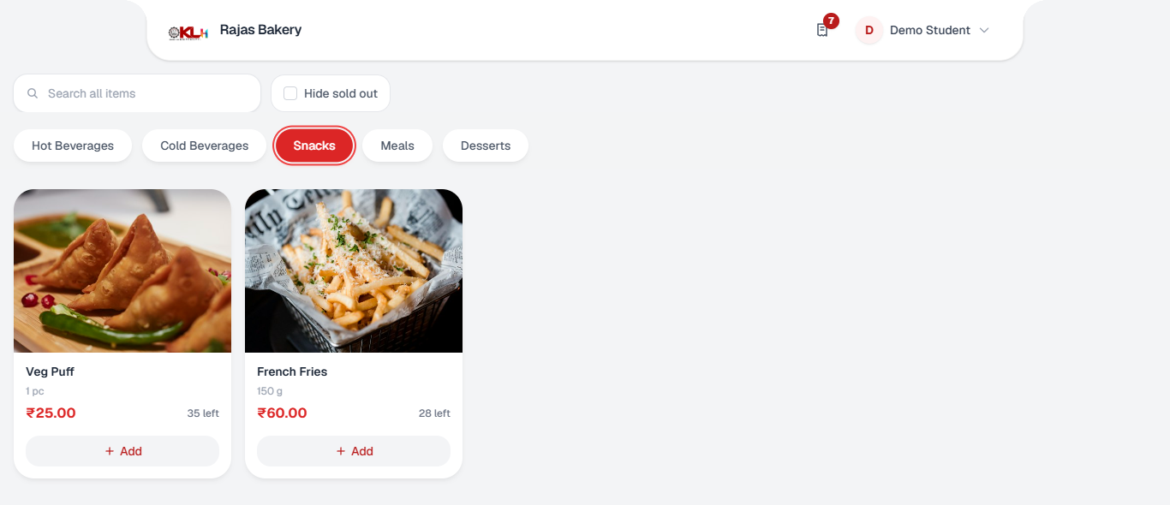
Figure 7.3: Student menu with live stock
Items are grouped by category with price, serving size and the number left; sold-out items can be hidden with one tick. Stock counts and availability update through the real-time stream without reloading the page.
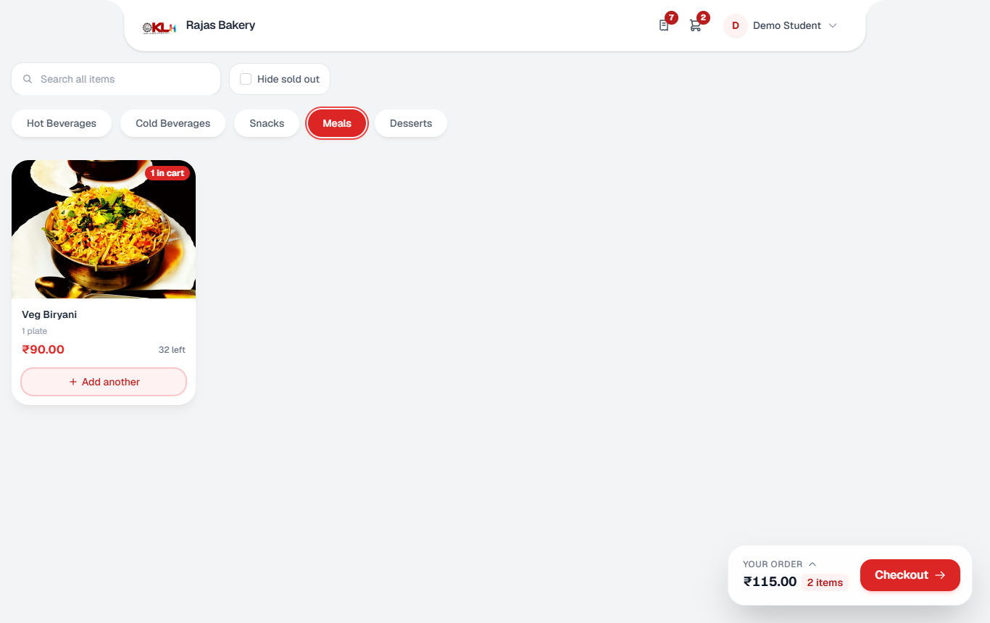
Figure 7.4: Cart bar after adding items
The bottom bar shows the running total and item count, and the card of an item already in the cart changes to Add another. Quantities are clamped to the available stock, so the cart can never request more than exists.
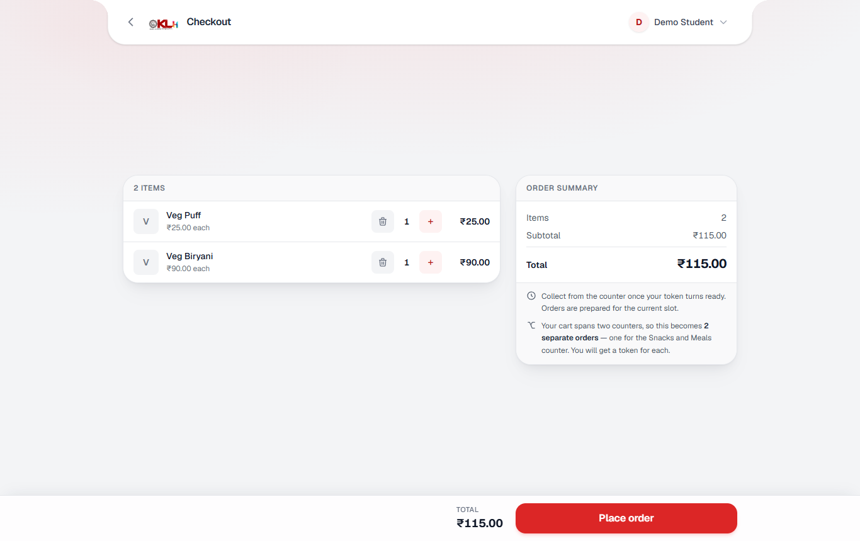
Figure 7.5: Checkout and order summary
The summary lists each line with editable quantity and explains that a cart spanning two counters becomes two separate orders. Place order creates the orders and, when payments are enabled, hands the student to the UPI payment page.
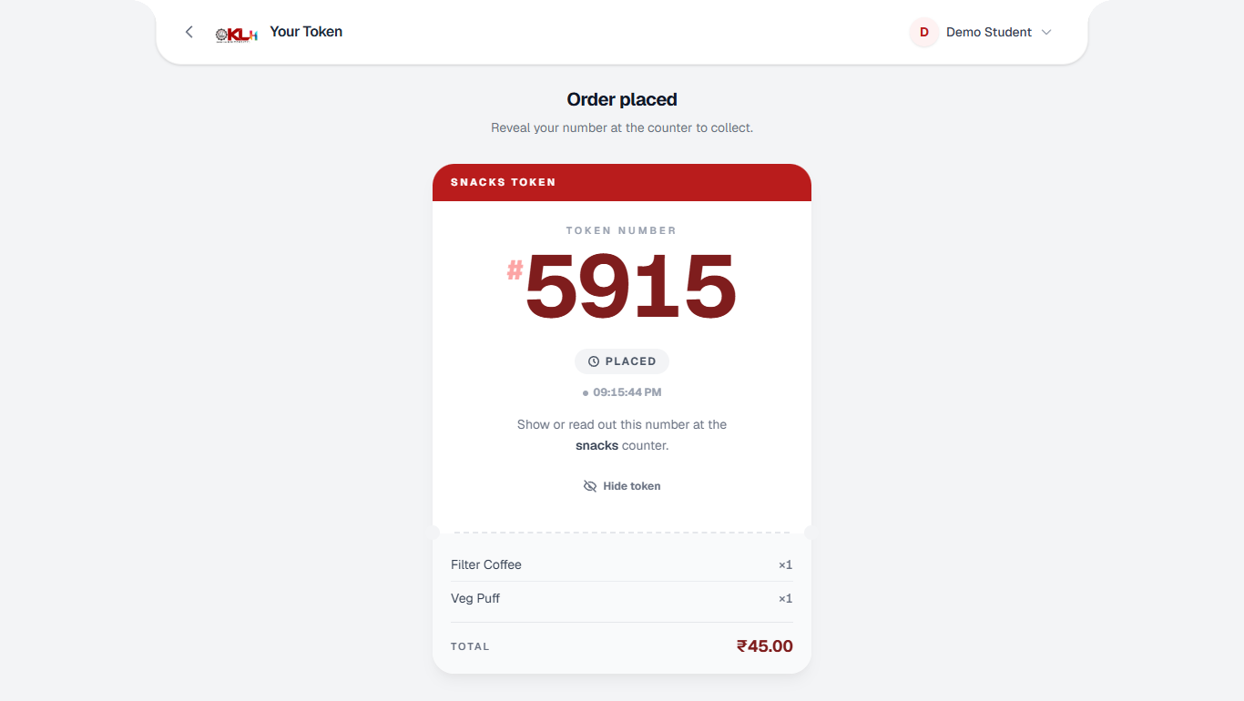
Figure 7.6: Order token
After ordering, the student sees a four-digit token for the correct counter (Snacks or Meals) and the time it was placed. The number is revealed only when the student chooses Show token, and the status chip updates live (Placed, Ready to collect).
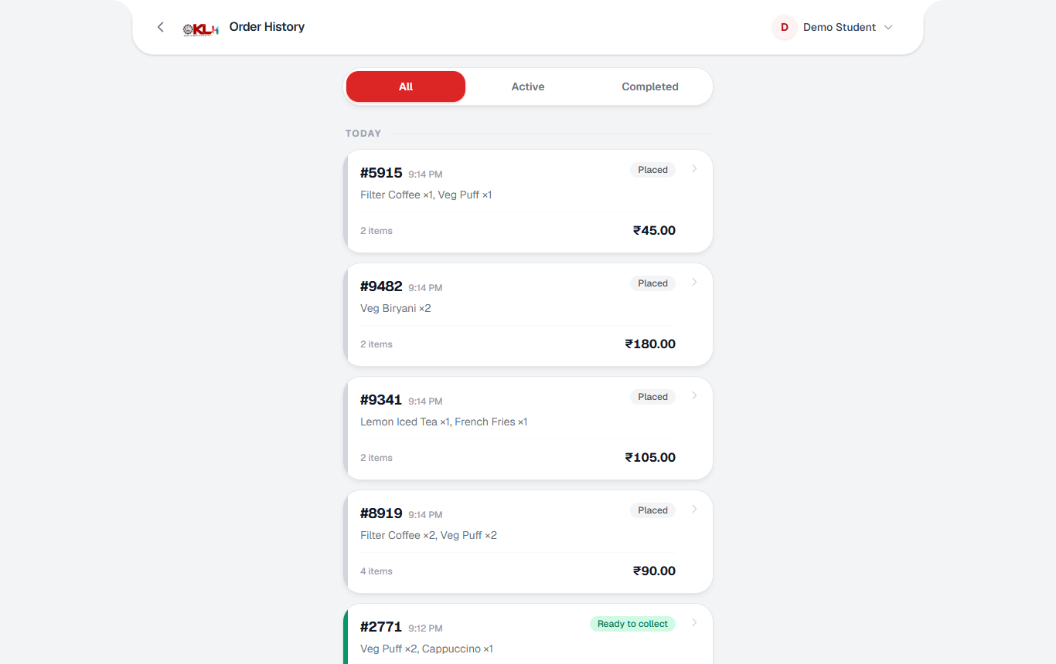
Figure 7.7: Order history
All past and active orders are listed newest first with items, total and a coloured status chip; filters switch between All, Active and Completed. Tapping an order opens its token page.
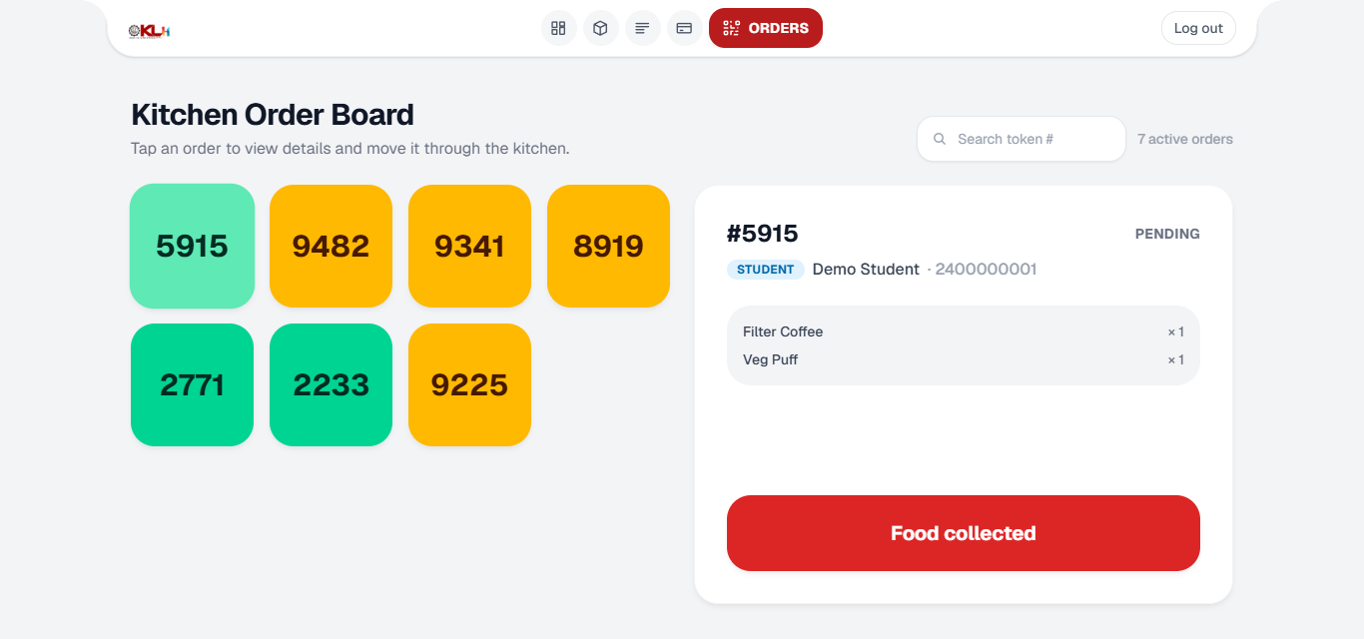
Figure 7.8: Kitchen order board
Each open order is a coloured tile showing its token number; tapping a tile shows the student, the items and the next action button. New orders appear instantly through the SSE stream, and the Food collected button completes the order.
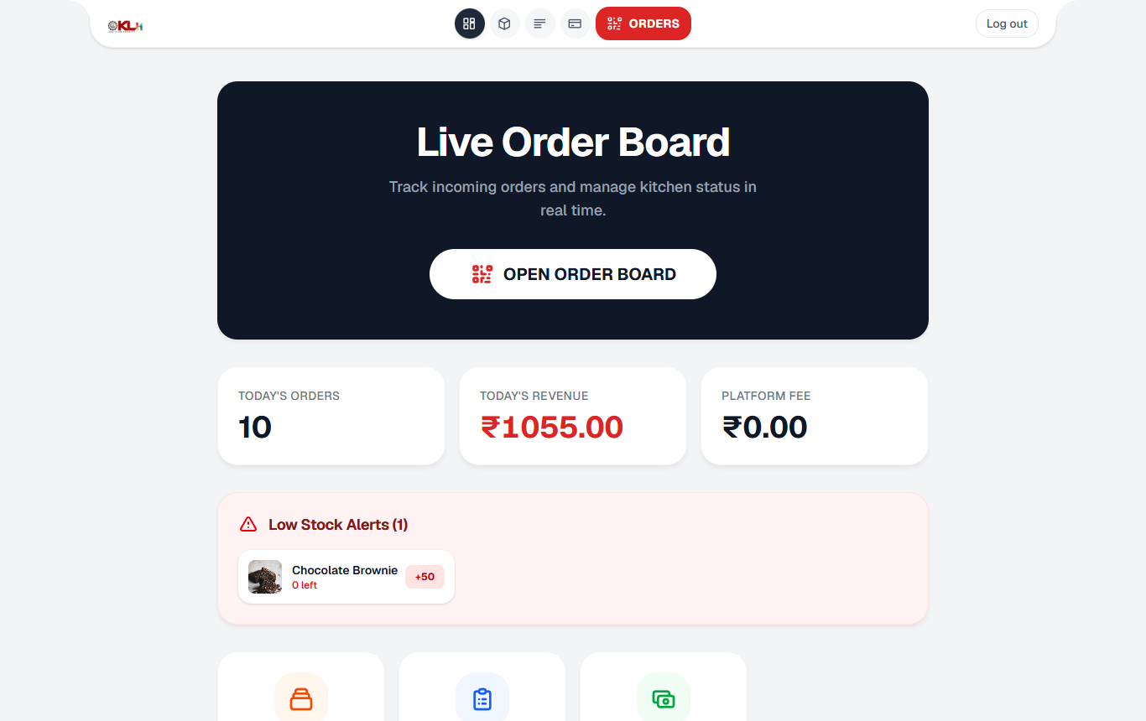
Figure 7.9: Admin dashboard
The dashboard shows today's orders, revenue and platform fee, with low-stock alerts that offer a quick restock amount. A single button opens the live order board for the counter.
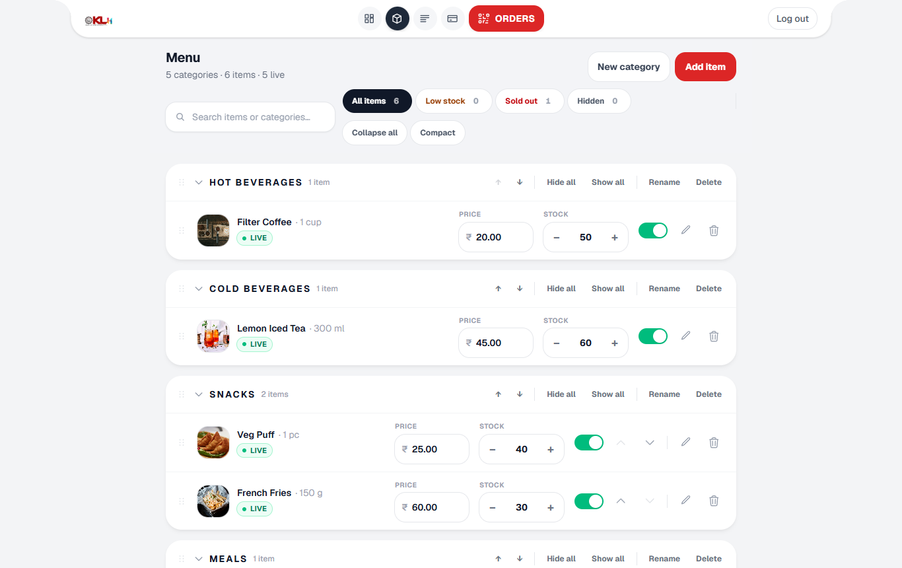
Figure 7.10: Inventory and menu management
Admins edit price and stock inline, hide items with a toggle, reorder items and categories, and filter by low stock or sold out. Changes are pushed to every student's menu in real time.
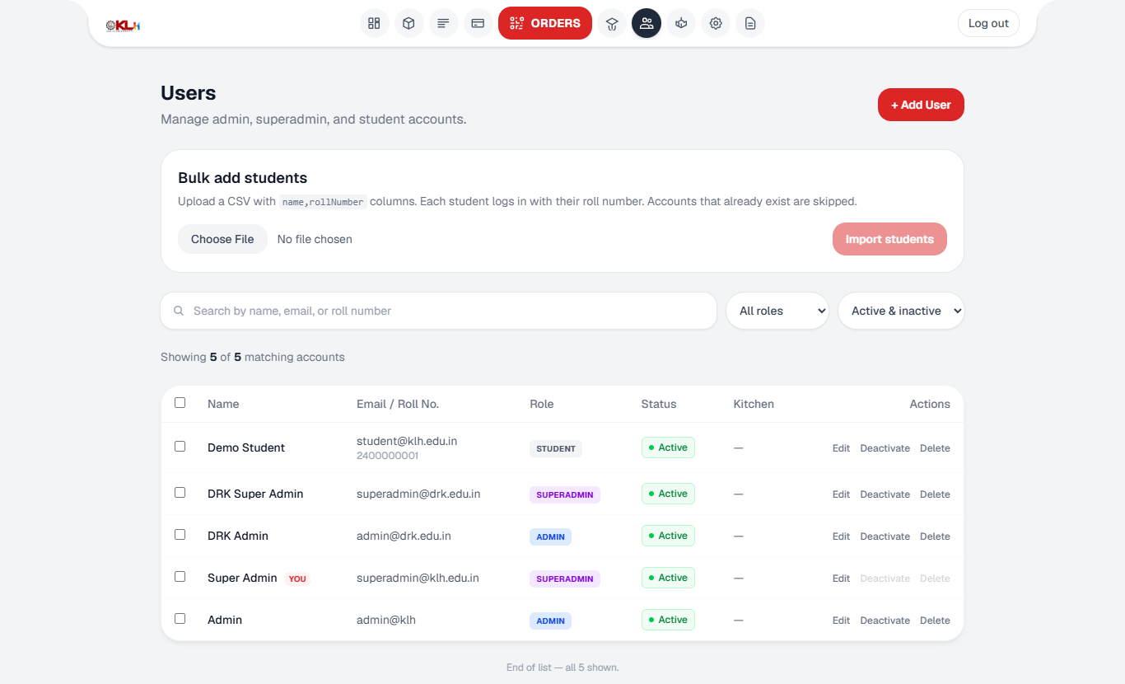
Figure 7.11: Super-admin user management
The super admin can add, edit, deactivate or delete accounts, filter by role and status, and bulk-import students from a CSV file. Deactivation rather than deletion preserves order history.
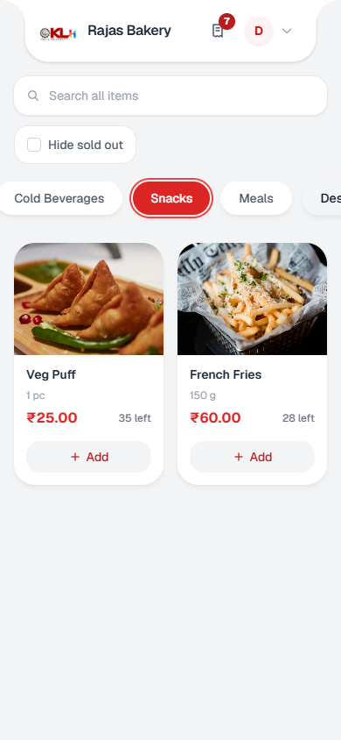
Figure 7.12: Student menu on a phone (390 x 844)
On a phone the layout collapses to a two-column card grid with horizontally scrolling category tabs. All primary actions remain reachable with one thumb.

Automated Test Results
Both test suites were executed on the delivered source (Windows 11, Node 24.21, PostgreSQL 16 in Docker). Table 7.1 gives the outcome; all 485 tests passed. The backend suite needs two environment settings that are specific to the payment tests (GURUPAY_API_KEY) and to the database guard test (a live DATABASE_URL in .env to protect), without which 11 tests report a configuration failure rather than a defect.
Table 7.1: Automated test outcomes
Suite | Files | Tests | Result | Scope
Frontend (Vitest) | 31 | 233 | 233 passed | Contexts, hooks, pages, components, property tests
Backend (Vitest + Supertest) | 20 | 252 | 252 passed | Auth, orders, guest, pre-booking, payments, fees, rate limit, realtime hub, imports
Total | 51 | 485 | 485 passed

Discussion
Table 7.2 relates the outcome to the objectives stated in Chapter 4.
Table 7.2: Objectives and how they were met
# | Objective | How it was met
1 | Fast, mobile ordering | Responsive SPA with lazy-loaded routes, live menu per school (Figures 7.3 to 7.12).
2 | No overselling | Single conditional UPDATE claim with compensation and a reconciliation sweep; covered by order and guest tests.
3 | Verified payments | Webhook treated as a hint; check-status call, amount match, row lock and idempotency; covered by paymentSettlement tests.
4 | Live board and token | Kitchen board with SSE deltas; random four-digit tokens unique among open orders.
5 | Walk-up guests | HMAC guest sessions with Google-derived stable ids; no account created.
6 | Access control and audit | Role checks from the database row, school scoping, audit log, forced password change.
7 | Real time without refetch | Protocol v2 deltas, sharded hubs, 150 ms coalescing, resume log.
8 | Serverless and tested | Cloudflare Workers + Neon + Vercel deployment; 485 automated tests.

Several design decisions are worth highlighting. Moving from a transaction around the whole basket to two short atomic statements removed row locks held across the network; moving from "something changed" events to data-carrying deltas removed the largest scaling defect of the first version; and keying the rate limiter on identity made it safe behind a campus NAT. The limitations are equally clear. The payment flow depends on a single gateway whose webhook cannot be authenticated, so correctness rests on the check-status call. The local Node hub fans out inside one process and is intended for development only. No sustained-load figures are reported in this document, and the screenshots show demonstration data rather than production orders.

CONCLUSION & FUTURE SCOPE

Conclusion
The KLH Pantry App meets the objectives set at the start of the project. Students can order from a live, school-specific menu on their phones and collect food with a short token; stock is reserved atomically so that no item is sold twice; payments release food only after the gateway has independently confirmed the money; and kitchen staff, administrators and super admins each work in an interface that updates in real time. The platform is deployed on a serverless stack, protected by identity-based rate limiting, role checks and an audit trail, and verified by 485 automated tests.
The main lesson of the project is that correctness under concurrency has to be designed into the data layer: the conditional stock claim, the partial unique index on open order numbers and the row-locked payment settlement each replace an assumption that would have failed at the lunch rush. A second lesson is that an unauthenticated third-party callback must be treated as noise, and its truth obtained from the source.

Future Scope

Near term
- Progressive-web-app installation with browser push notifications, so that students without Telegram are also alerted when food is ready.
- Continuous integration that runs both test suites and the Playwright specification on every commit, and wider end-to-end coverage of the payment flow.
- Printable order slips and downloadable invoices for students.

Medium term
- Sales analytics: peak-hour heat maps, item-wise demand and stock-out reports to guide purchasing.
- Support for several vendors per campus and per-vendor settlement, building on the existing payout model.
- Ratings and feedback on items, and favourites or re-order shortcuts for returning students.
- Scheduled specials and menu templates by weekday.

Long term
- Demand forecasting from historical orders to reduce food waste and to suggest preparation quantities.
- Integration with the university ERP and student identity card for single sign-on and meal-plan billing.
- Native mobile applications and, where the institution wishes, delivery to hostels or departments.
- A multi-tenant version that onboards other colleges without code changes.

REFERENCES
[1] subhodeepmodak, "QuickBite" (fork of ajaykumarn3000/QuickBite), GitHub repository. https://github.com/subhodeepmodak/QuickBite
[2] AnkitKumar8080, "CampusDine," GitHub repository. https://github.com/AnkitKumar8080/CampusDine
[3] codevaam, "Canteen-Management-System," GitHub repository. https://github.com/codevaam/Canteen-Management-System
[4] danishsshaikh, "KCCafeteria," GitHub repository. https://github.com/danishsshaikh/KCCafeteria
[5] devmehtaa, "SCOS: Smart Canteen Ordering System," GitHub repository. https://github.com/devmehtaa/SCOS
[6] zs0c131y, "CampusBite," GitHub repository. https://github.com/zs0c131y/CampusBite
[7] Pratham211, "College Canteen Management System," val.town project. https://www.val.town/x/Pratham211/canteen
[8] "Evaluating the Impact of Quick-Eats on Student Experience and Canteen Operations at IOBM," Journal of Information and Communication Technology, ILMA University, vol. 19, no. 1, 2025. https://jict.ilmauniversity.edu.pk/arc/Vol19/i1p5
[9] Hono, "Hono web framework documentation." https://hono.dev/
[10] Cloudflare, "Cloudflare Workers documentation." https://developers.cloudflare.com/workers/
[11] Cloudflare, "Durable Objects documentation." https://developers.cloudflare.com/durable-objects/
[12] Neon, "Neon serverless Postgres documentation." https://neon.com/docs/introduction
[13] Meta Open Source, "React documentation." https://react.dev/
[14] Vite, "Vite documentation." https://vite.dev/
[15] Tailwind Labs, "Tailwind CSS documentation." https://tailwindcss.com/docs
[16] Mozilla, "Server-sent events," MDN Web Docs. https://developer.mozilla.org/en-US/docs/Web/API/Server-sent_events
[17] Google, "Sign in with Google for Web," Google for Developers. https://developers.google.com/identity/gsi/web/guides/overview
[18] Telegram, "Telegram Bot API." https://core.telegram.org/bots/api
[19] NPCI, "Unified Payments Interface (UPI): product overview." https://www.npci.org.in/what-we-do/upi/product-overview
[20] PostgreSQL Global Development Group, "Explicit locking," PostgreSQL 16 documentation. https://www.postgresql.org/docs/16/explicit-locking.html
[21] Vitest, "Vitest documentation." https://vitest.dev/

